Chapter Two: The Energies And Environments
The Energies and Environments are a new system which defines 12 abstract powers (the Energies) and 12 environmental powers (the Environments). This system is similar to, but not identical with, the zodiac and planets. However, they have no relationship to the calendar and are not used for fortune telling.

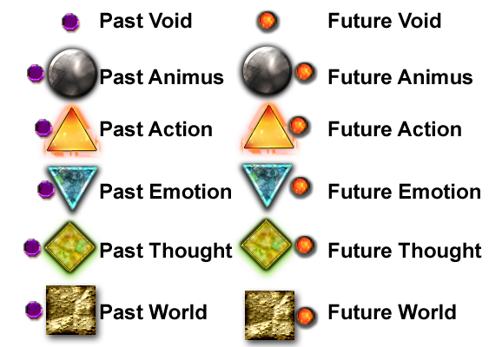
The Energies
The Energies are a system of 12 elements. These symbols represent the six elemental powers: Void (a new element introduced with this system), Animus, Action, Emotion, Thought, and World supplemented with the concepts of past and future.

Animus, Action, Emotion, Thought, and World are similar to Spirit, Fire, Water, Air, and Earth of the old elemental system. When combined with the concepts of past and future, Action, Emotion, Thought, and World correspond exactly to the I Ching symbols as follows:

Energy | I Ching | Energy | I Ching
Past Action | ☳ Thunder (Chên) | Future Action | ☰ Heaven (Ch'ien)
Past Emotion | ☱ Joy or Lake (Tui) | Future Emotion | ☲ Fire (Li)
Past Thought | ☵ Water (K'an) | Future Thought | ☶ Mountain (Kên)
Past World | ☷ Earth (K'un) | Future World | ☴ Wind (Sun)

Void
Void is a new element. It is the counterpart to Spirit, just as Water and Fire are counterparts, and Air and Earth are counterparts. Void represents nothing, in the sense of 0 = 1 + -1. Its interesting properties are 1) it can be added to anything at all without changing the receiver, and 2) pairs of opposites (1/-1, 2/-2, etc.) can be extracted from it indefinitely.

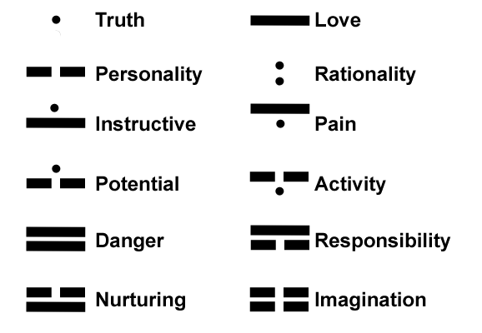
The Environments
The Environments are a system of 12 influencing powers. They are somewhat similar in purpose to the planets in astrology. The two basic environments are Truth and Love. These interact to create Personality. Truth, Love, and Personality combine in pairs to create the remaining 9 Environments, for a total of 12. Their meanings are exactly what their names indicate.

The Environments As Logograms
The environments were interpreted as logograms to determine their meanings. This is interpretation is described here. For the symbols with two lines, the top line represents the environment the individual is in, the bottom line represents the individual.

Truth – The dot represents simple existence. A is A.
Love - A line connecting two separate points.
Personality – The interaction of truth and love.
Rationality – Truth in the environment, truth in the individual.
Instructive – An individual's Love for truth in the environment. A person letting the truth of the environment teach him.
Pain – The difficulty of bringing truth to an environment of love.
Potential – A seed breaking through the earth. A person beginning to see the truth.
Activity – Energy below the surface starting to break through. A person bringing truth to friends.
Danger – The danger of being blinded by love, seeing nothing else.
Responsibility - A house. Love guides the individual's personality.
Nurturing – Female breasts. Love for the personality of the environment one is in.
Imagination – The interaction of the energy of personality coming from both the individual and his environment.

Strengthening And Weakening
Just as the planets have a relationship with the zodiac signs, so to do the Energies have a relationship with the Environments. Certain pairs of Energies and Environments can mutually strengthen or weaken one another, as shown in the diagrams below.
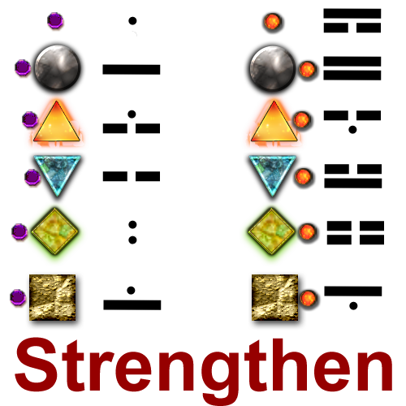
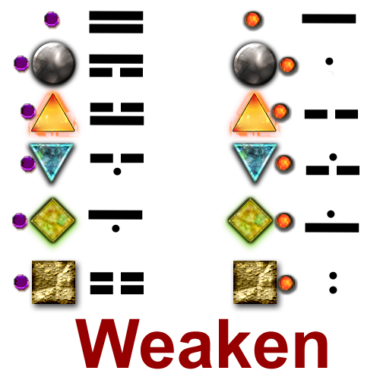

Aleister Crowley provided similar correspondences to the symbols of the I Ching in his book “777”. Do not mistake the Energies as being nothing more than new symbols for these correspondences. That is not the case. I believe that Crowley's correspondences were flawed. This will be discussed in more detail in a future chapter.

